6/5/17

Download + Installation

To Source the freesurfer environment:

* export FREESURFER_HOME=/Applications/freesurfer  
  source $FREESURFER_HOME/SetUpFreeSurfer.sh
* export SUBJECTS_DIR=/Users/jessicahuang/Desktop/Subjects

Configuration

License

White matter segmentation: wm.mgz

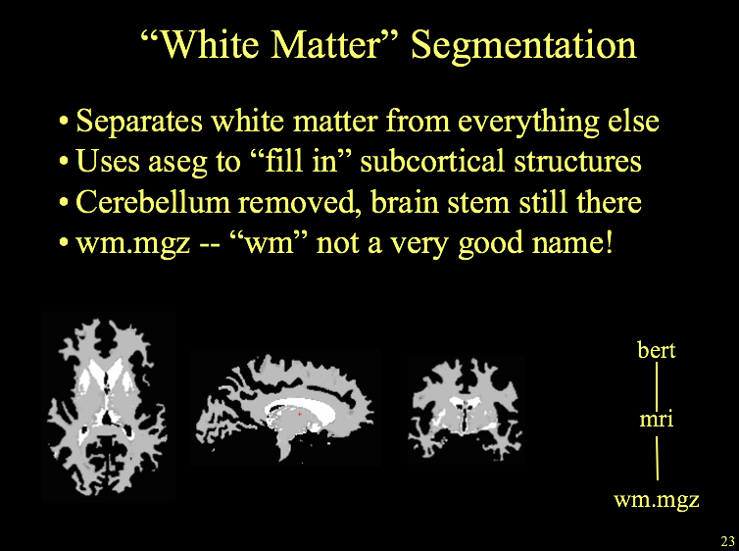

How to use recon-all: <https://surfer.nmr.mgh.harvard.edu/fswiki/recon-all>

Testing correct installation: <https://surfer.nmr.mgh.harvard.edu/fswiki/DownloadAndInstall#TestyourFreeSurferInstallation>

* recon-all -s subjid -all (Perform a full recon-all on a pre-existing subject folder)
* recon-all -i sample-001.nii.gz -s bert -all (creates a folder called bert in SUBJECTS_DIR)
  + sample-001.nii.gz is whichever directory you’re currently in

<https://surfer.nmr.mgh.harvard.edu/fswiki/FreeSurferBeginnersGuide>

recon-all \  
 -i <one slice in the anatomical dicom series> \  
 -s <subject id that you make up> \  
 -sd <directory to put the subject folder in> \  
 -all

export SUBJECT_DIR=/Users/jessicahuang/Desktop/Subjects

recon-all -i sample-001.nii.gz -s berta -all

recon-all -i WXY207_WangAihong-1004-t1_mprage_sag_iso_mww-00001.dcm -subject S02_WAH_mprage -all

Where to locate white matter segmentations

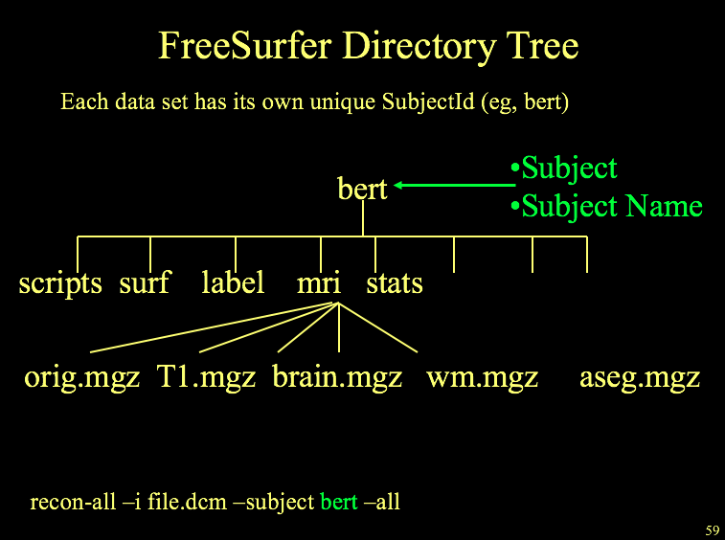

Tutorial #1: Output Data

<http://freesurfer.net/fswiki/FsTutorial/OutputData_freeview>

**Viewing outputs**

To access the viewer

cd $SUBJECTS_DIR

freeview -v \  
good_output/mri/T1.mgz \  
good_output/mri/wm.mgz \  
good_output/mri/brainmask.mgz \  
good_output/mri/aseg.mgz:colormap=lut:opacity=0.2 \  
-f good_output/surf/lh.white:edgecolor=blue \  
good_output/surf/lh.pial:edgecolor=red \  
good_output/surf/rh.white:edgecolor=blue \  
good_output/surf/rh.pial:edgecolor=red

good_output = subject name

Once inside the viewer

%**Keyboard Shortcut**: Alt+c will allow you to quickly cycle through all the layers. Every time you hit it, the volume at the top of the list will move to the bottom of the list.

FOR REFERENCE: here’s a successful recon-all

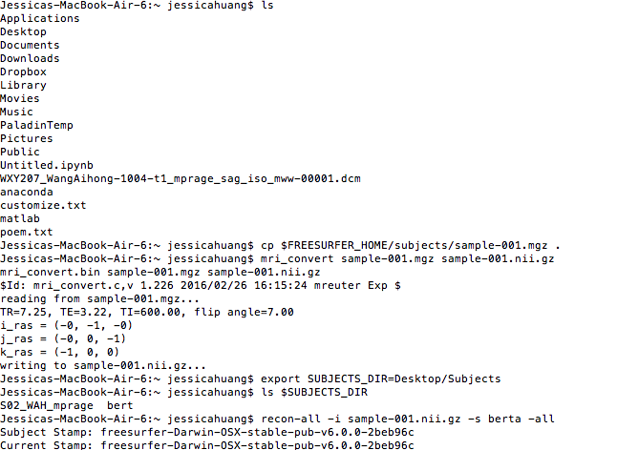

Commands involved:

export SUBJECTS_DIR=Desktop/Subjects

recon-all -i sample-001.nii.gz -s berta -all

Commentary

*sample-001.nii.gz was in the working directory

*berta is a new folder that’ll be created in the SUBJECTS_DIR

Try this too:

Version 1:

recon-all -i WXY207_WangAihong-1004-t1_mprage_sag_iso_mww-00001.dcm -s S02_WAH_mprage -sd Desktop/Subjects -all

Version 2:

recon-all -i WXY207_WangAihong-1004-t1_mprage_sag_iso_mww-00001.dcm -sd Desktop/Subjects/SO2_WAH_mprage -all

In another terminal window, try to use the freesurfer viewer! (example 4: <https://surfer.nmr.mgh.harvard.edu/fswiki/DownloadAndInstall#TestyourFreeSurferInstallation> )

Running on the Monster Mac:

export SUBJECTS_DIR=/Users/caramazzalab/Desktop/Jess/Subjects

cd /Users/caramazzalab/Desktop/Jess/RAW_data/S02_WAH_mprage/

**Desktop 1**:

recon-all \

-i WXY207_WangAihong-1004-t1_mprage_sag_iso_mww-00001.dcm \

.

.

.

-i WXY207_WangAihong-1004-t1_mprage_sag_iso_mww-00192.dcm \

-s S02_WAH_mprage \

-all

**Desktop 2**:

recon-all \

-i WXY203^ChouYanrong-0003-0001-00001.dcm \

.

.

.

-i WXY203^ChouYanrong-0003-0001-00192.dcm \

-s S02_QYR_mprage \

-all

Methods of Running Recon-all:

*does work but isn’t very automatic

recon-all \

-i WXY207_WangAihong-1004-t1_mprage_sag_iso_mww-00001.dcm \

.

.

.

-i WXY207_WangAihong-1004-t1_mprage_sag_iso_mww-00192.dcm \

-s S02_WAH_mprage \

-all

**doesn’t work, only one file found

recon-all \

-i WXY207_WangAihong-1004-t1_mprage_sag_iso_mww-00001.dcm \

-s S02_WAH_mprage \

-all

**doesn’t work, there needs to be an ‘-i’ in front of all files

recon-all \

-i /Users/caramazzalab/Desktop/Jess/RAW_data/S02_WAH_mprage/* \

-s S02_WAH_mprage \

-all

**doesn’t work, you need the -i flag

recon-all \

-i /Users/caramazzalab/Desktop/Jess/RAW_data/S02_WAH_mprage/ \

-s S02_WAH_mprage \

-all

<pending new method featuring a bash script! See <https://docs.google.com/a/college.harvard.edu/document/d/1WTTz6f27SL8nVFojtYCExjpmmEY7IjZg5LJD2RvHoFU/edit?usp=sharing> >

Time Scale of recon-all .nifti

On my mac:

|  |  |
| --- | --- |
| Step | Time Stamp |
| Autorecon Processing Stages (see -autorecon# flags above):  1. Motion Correction and Conform  2. NU (Non-Uniform intensity normalization)  3. Talairach transform computation  4. Intensity Normalization 1  5. Skull Strip  6. EM Register (linear volumetric registration)  7. CA Intensity Normalization  8. CA Non-linear Volumetric Registration  9. Remove neck  10. EM Register, with skull  11. CA Label (Aseg: Volumetric Labeling) and Statistics  12. Intensity Normalization 2 (start here for control points)  13. White matter segmentation  14. Edit WM With ASeg  15. Fill (start here for wm edits)  16. Tessellation (begins per-hemisphere operations)  17. Smooth1  18. Inflate1  19. QSphere  20. Automatic Topology Fixer  21. White Surfs (start here for brain edits for pial surf)  22. Smooth2  23. Inflate2  24. Spherical Mapping  25. Spherical Registration  26. Spherical Registration, Contralater hemisphere  27. Map average curvature to subject  28. Cortical Parcellation (Labeling)  29. Cortical Parcellation Statistics  30. Pial Surfs  31. WM/GM Contrast  32. Cortical Ribbon Mask  33. Cortical Parcellation mapped to ASeg  34 Brodmann and exvio EC labels | #--------------------------------------------  #@# MotionCor Mon Jun 5 15:30:38 EDT 2017  #--------------------------------------------  #@# Talairach Mon Jun 5 15:30:47 EDT 2017  #--------------------------------------------  #@# Nu Intensity Correction Mon Jun 5 15:32:18 EDT 2017  #--------------------------------------------  #@# Intensity Normalization Mon Jun 5 15:34:16 EDT 2017  #--------------------------------------------  #@# Skull Stripping Mon Jun 5 15:36:53 EDT 2017  #-------------------------------------  #@# EM Registration Mon Jun 5 15:59:16 EDT 2017  #--------------------------------------  #@# CA Normalize Mon Jun 5 16:19:54 EDT 2017  #--------------------------------------  #@# CA Reg Mon Jun 5 17:15:26 EDT 2017  #--------------------------------------  #@# SubCort Seg Mon Jun 5 22:43:31 EDT 2017  #--------------------------------------  #@# Merge ASeg Tue Jun 6 10:09:10 EDT 2017  \n cp aseg.auto.mgz aseg.presurf.mgz \n  #--------------------------------------------  #@# Intensity Normalization2 Tue Jun 6 10:09:10 EDT 2017  #--------------------------------------------  #@# Mask BFS Tue Jun 6 10:13:00 EDT 2017  #--------------------------------------------  #@# WM Segmentation Tue Jun 6 10:13:02 EDT 2017  #--------------------------------------------  #@# Fill Tue Jun 6 10:15:29 EDT 2017  #--------------------------------------------  #@# Tessellate lh Tue Jun 6 10:16:15 EDT 2017  #--------------------------------------------  #@# Tessellate rh Tue Jun 6 10:16:22 EDT 2017  #--------------------------------------------  #@# Smooth1 lh Tue Jun 6 10:16:29 EDT 2017  #--------------------------------------------  #@# Smooth1 rh Tue Jun 6 10:16:39 EDT 2017  #--------------------------------------------  #@# Inflation1 lh Tue Jun 6 10:16:49 EDT 2017  #--------------------------------------------  #@# Inflation1 rh Tue Jun 6 10:17:24 EDT 2017  #--------------------------------------------  #@# QSphere lh Tue Jun 6 10:18:00 EDT 2017  #--------------------------------------------  #@# QSphere rh Tue Jun 6 10:21:36 EDT 2017 |

**FINAL: RECON-ALL SUBJECTS PROCEDURE**

Using script: recon-all-dicom.sh inside RAW_data

It’s a scanner, so put in the folder name and you’ll be all set

**VIEWING SUBJECTS**

$> cd $SUBJECTS_DIR  
$> freeview -v \  
 bert/mri/T1.mgz \  
 bert/mri/wm.mgz \  
 bert/mri/brainmask.mgz \  
 bert/mri/aseg.mgz:colormap=lut:opacity=0.2 \  
 -f \  
 bert/surf/lh.white:edgecolor=blue \  
 bert/surf/lh.pial:edgecolor=red \  
 bert/surf/rh.white:edgecolor=blue \  
 bert/surf/rh.pial:edgecolor=red

Guide to commands with viewing: <https://surfer.nmr.mgh.harvard.edu/fswiki/FreeviewGuide/FreeviewGeneralUsage/FreeviewQuickStart>

Icons: <https://surfer.nmr.mgh.harvard.edu/fswiki/FreeviewGuide/FreeviewTools/VoxelEdit>

Editing segmentation and parcellation: <https://surfer.nmr.mgh.harvard.edu/fswiki/FreeviewGuide/FreeviewTools/VoxelEdit>

GENERAL EDITING

<https://surfer.nmr.mgh.harvard.edu/fswiki/Edits>

EDITING PIAL SURFACES

<https://surfer.nmr.mgh.harvard.edu/fswiki/FsTutorial/PialEdits_tktools>

<http://freesurfer.net/fswiki/FsTutorial/PialEdits_freeview>

EDITING WHITE MATTER SURFACES

<https://surfer.nmr.mgh.harvard.edu/fswiki/FsTutorial/WhiteMatterEdits_freeview>

VIEWING 3D SURFACES

<http://freesurfer.net/fswiki/FsTutorial/OutputData_freeview>

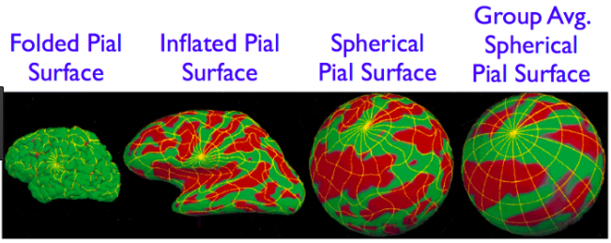

Relevant files to load

**Volumes**

T1.mgz

brainmap.mgz

**Surfaces**

lh.white

lh.pial

rh.white

rh.pial

lh.inflated

rh.inflated

Good commands to color the lines automatically:

$> cd $SUBJECTS_DIR  
$> freeview -v \  
 bert/mri/T1.mgz \  
 bert/mri/wm.mgz \  
 bert/mri/brainmask.mgz \  
 bert/mri/aseg.mgz:colormap=lut:opacity=0.2 \  
 -f \  
 bert/surf/lh.white:edgecolor=blue \  
 bert/surf/lh.pial:edgecolor=red \  
 bert/surf/rh.white:edgecolor=blue \  
 bert/surf/rh.pial:edgecolor=red

Want to run recon-all to create just one more new file?

<http://freesurfer.net/fswiki/ReconAllTableStableV5.1> here are the flags

Here’s a relevant FAQ: <http://freesurfer.net/fswiki/UserContributions/FAQ#Q.Oneormoreofthefilesinasubject.27sdirectorywasaccidentallydeletedorhasbecomecorrupted.HowdoIrecreatethemissingfile.28s.29.3F>

Transitioning to matlab: **Q. Can I load FreeSurfer output in Matlab?**

A: If you write it as .mgz format then load_mgh (or MRIread) will read it

**The problem with all the errors!**

<https://mail.nmr.mgh.harvard.edu/pipermail//freesurfer/2015-November/042168.html>

Only feed in one dicom file - if you feed in more than one, you’ll get the (identical images?) error

**Which dicom file do you feed into recon-all?**

Figure it out based on this message: <https://mail.nmr.mgh.harvard.edu/pipermail//freesurfer/2014-March/036583.html>

dcmunpack -src /Users/caramazzalab/Desktop/Jess/RAW_data/S02_WAH_mprage → shows first dicom file HM let’s see if this works by just passing in *

**To view subjects use the following scripts**:

An interactive script for viewing pial and wm is /Users/caramazzalab/Desktop/Jess/Subejcts/view-pial-wm.sh. An interactive script for viewing inflated hemispheres is

**What code do I run after I spot an error in freesurfer**?

A cheat sheet on troubleshooting: <https://surfer.nmr.mgh.harvard.edu/fswiki/FsTutorial/TroubleshootingData>

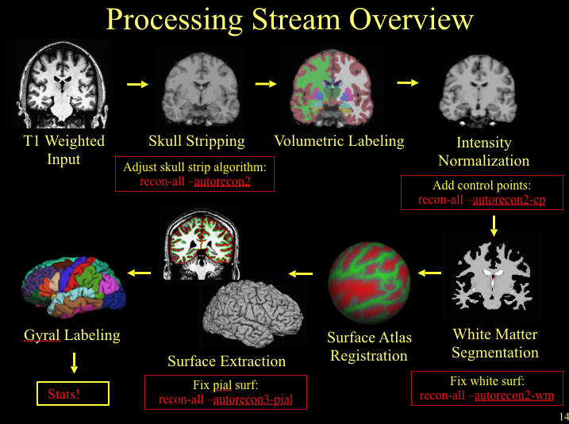

After pial surface: recon-all autorecon3.pial

Error #1: Too much included in gray matter

Upper brain scans:

* How to fix: **erasing dura/blood vessels/optic tract**
  + Edit brainmask.mgz and erase dura/blood vessels
  + Run: recon-all -s <subejct> -autorecon-pial
* Characterize the problem:
  + Dura at the top of the brain is included in the gray matter

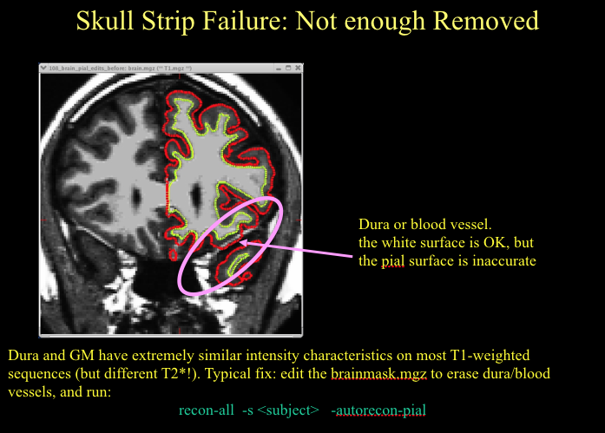

Middle brain scans:

* How to fix: **erasing dura/blood vessels/optic tract**
  + Edit brainmask.mgz and erase dura/blood vessels
    - Follow instructions on editing brainmask.mgz here: <https://surfer.nmr.mgh.harvard.edu/fswiki/FsTutorial/PialEdits_freeview>
    - Click edit button with the R inside a brain
    - Hit brush size = 2
    - Check off recon editing
    - Make sure brainmask.mgz is highlighted on the left
    - Hold down shift and left click voxels you want to clear
    - File save volume
  + Run: recon-all -s <subject> -autorecon-pial
* Characterizing the problem:
  + Optic tract is not gray matter but is clustered as gray matter

Error #2: Not enough included in white matter

To fix lower brain scans: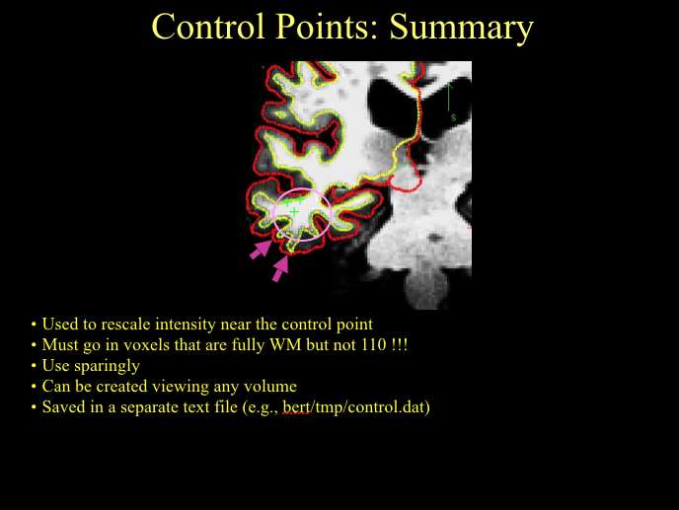

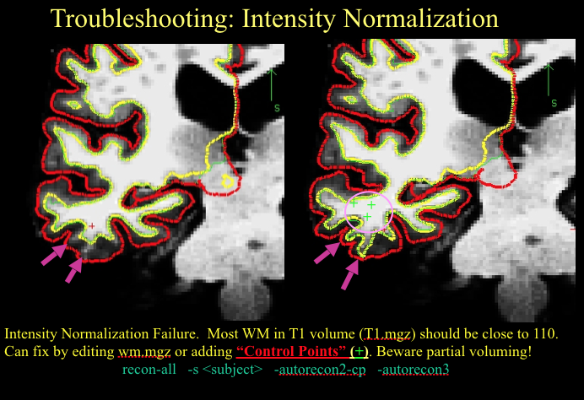

* How to fix
  + Add **control points** to the place you know should be marked as white matter
    - Here are directions on adding control points <https://surfer.nmr.mgh.harvard.edu/fswiki/FsTutorial/ControlPoints_freeview>
    - File > new point set > control.dat
    - File > save point set > control.dat
  + Save control points as a file bert/tmp/control.dat
  + Run: recon-all -s <subject> -autorecon2-cp -autorecon3
* Characterizing the problem:
  + Towards the bottom slices of the brain, intensity differences between white matter and gray matter diminishes - white matter starts to look darker/ more like gray matter
  + Ex. the temporal lobe often is missing gray matter, so the move to extend the temporal lobe is to extend the white matter
  + Sometimes, white matter is missed, instead marked as gray matter, AND surrounding gray matter is missed too

Run for error 1 and 2 combined :

export FREESURFER_HOME=/Applications/freesurfer

source $FREESURFER_HOME/SetUpFreeSurfer.sh

export SUBJECTS_DIR=/Users/caramazzalab/Desktop/Jess/subjects

recon-all -autorecon-pial -autorecon2-cp -autorecon3 -s S02_WAH_mprage

export FREESURFER_HOME=/Applications/freesurfer

source $FREESURFER_HOME/SetUpFreeSurfer.sh

export SUBJECTS_DIR=/Users/caramazzalab/Desktop/Jess/subjects

recon-all -autorecon-pial -autorecon2-cp -autorecon3 -clean-cp -s S05_XYZ_mprage

export FREESURFER_HOME=/Applications/freesurfer

source $FREESURFER_HOME/SetUpFreeSurfer.sh

export SUBJECTS_DIR=/Users/caramazzalab/Desktop/Jess/subjects

recon-all -autorecon-pial -s B204_mprage

export FREESURFER_HOME=/Applications/freesurfer

source $FREESURFER_HOME/SetUpFreeSurfer.sh

export SUBJECTS_DIR=/Users/caramazzalab/Desktop/Jess/subjects

recon-all -autorecon-pial -autorecon2-cp -autorecon3 -s S06_YBH_mprage

Error #3: White matter defects - non continuity - sulci looks like WM (handles), WM looks like gray matter (holes)

* How to fix
  + Edit wm.mgz - for holes, fill voxels - for handles, erase voxels
  + Run: recon-all -s <subject> -autorecon3-pial
* Characterizing the problem
  + Hole: WM looks like gray matter
  + Handle: Some sulci is wrongly classified as WM

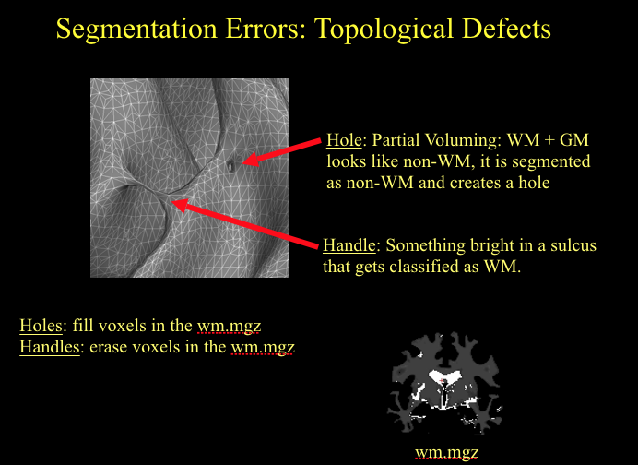

Next Steps: Functional Preprocessing

How do you load slice time into the pipeline?

How do you do multiband?